Test Plan – ParaBank Banking Application
Test Plan Identifier
parabank_tp_001
Introduction
The purpose of this test plan is to verify the functionality, usability, and navigation flow of the ParaBank Banking Application. Testing will be performed on the modules automated using Selenium WebDriver, Cucumber BDD, TestNG, Maven, Jenkins, and Extent Reports.
Test Items
- User Registration
- User Login
- Open New Account
- Transfer Funds
- Bill Payment
- Find Transactions
- Update Contact Information
- Request Loan
- Logout
Features To Be Tested
Registration
- User registration with valid details
- Mandatory field validation
- Registration submission
Evidence:
Refer Screenshot:
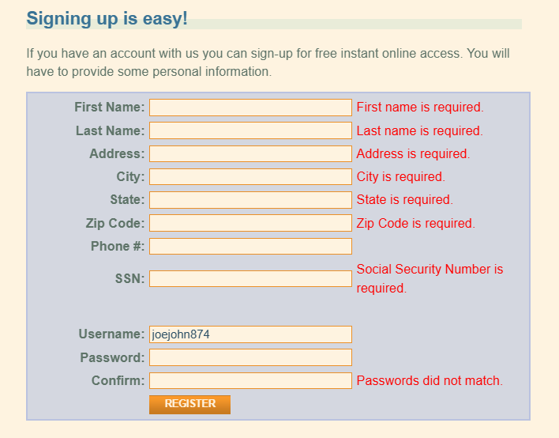

Login
- Login with valid credentials
- Login with invalid credentials
- Authentication validation
Evidence:
Refer Screenshot:
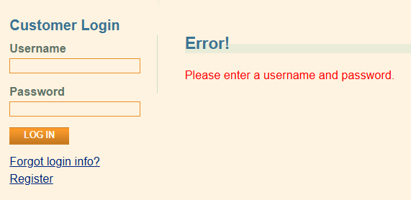

Open New Account
- Navigation to Open New Account page
- Account creation functionality
- Account details generation
Evidence:
Refer Screenshot:
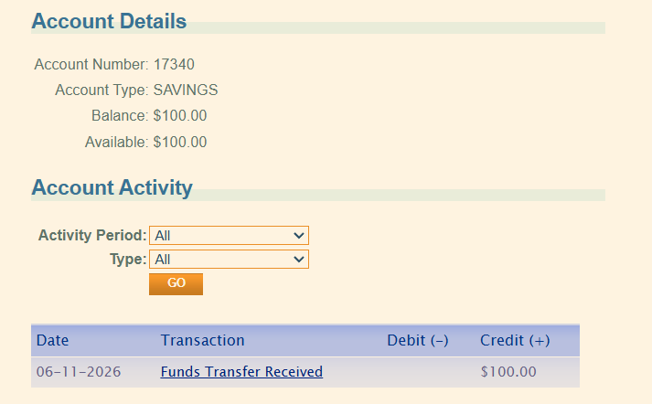

Transfer Funds
- Transfer funds between accounts
- Amount entry validation
- Account selection functionality
Evidence:
Refer Screenshot:
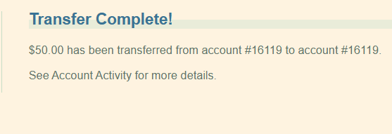
Bill Payment
- Bill Pay page navigation
- Payee details entry
- Bill payment submission
Evidence:
Refer Screenshot:
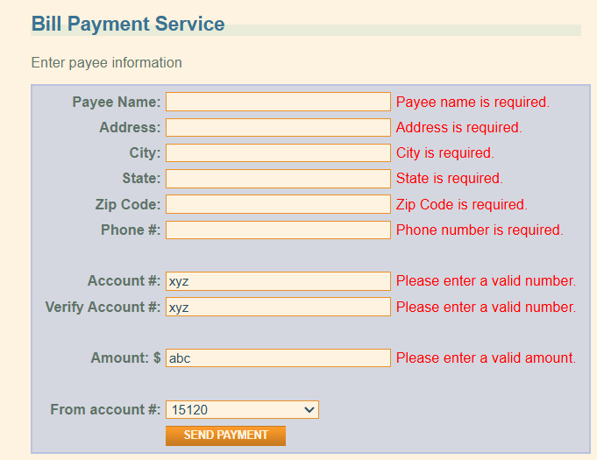
Find Transactions
- Date range search functionality
- Transaction retrieval
Evidence:
Refer Screenshot:
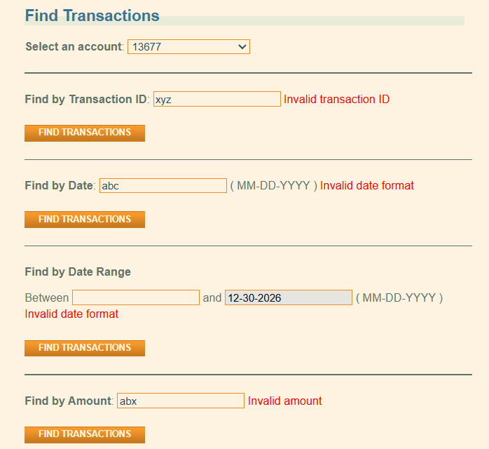
Update Contact Information
- Contact information update functionality
Evidence:
Refer Screenshot:
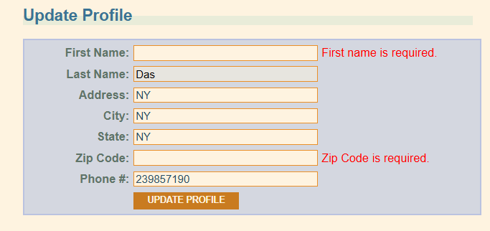

Request Loan
- Loan amount entry
- Down payment entry
- Loan application submission
Evidence:
Refer Screenshot:

Features Not To Be Tested
- Database validation
- API testing
- Performance testing
- Load testing
- Security testing
- Mobile application testing
Testing Approach
- Black Box Testing
- Manual Testing
- Automation Testing using Selenium WebDriver
- Functional Testing
- UI Testing
- Regression Testing
- Data-Driven Testing using Excel
- Cross Browser Testing (Chrome and Edge)
Item Pass / Fail Criteria
Total Test Cases
As per prepared test suite.
Pass Criteria
- Test case executes successfully.
- Actual Result matches Expected Result.
Fail Criteria
- Actual Result does not match Expected Result.
- Application behaviour deviates from expected functionality.

Suspension Criteria and Resumption Requirements
Suspension Criteria
- Application unavailable
- Server downtime
- Login functionality unavailable
- Test environment unavailable
- Critical functionality failure preventing further testing
Resumption Requirements
- Application restored
- Stable build deployed
- Critical defects fixed
- Test environment available
Test Deliverables
- Test Plan Document
- Test Cases Document
- Bug Report
- Automation Framework Document
- Test Execution Report
- Extent Report
- Automation Scripts
Environmental Needs
Software Requirements
- Windows 11
- Google Chrome Browser
- Microsoft Edge Browser
- Java
- Eclipse IDE
- Maven
- Selenium WebDriver
- Cucumber BDD
- TestNG
- Jenkins
- Apache POI
- Extent Reports
Hardware Requirements
- Minimum 8 GB RAM
- Stable Internet Connection
Risks and Contingencies
- Application downtime
- Test data dependency
- Browser compatibility issues
- Network connectivity issues
- Environment unavailability
Tools Used
- Selenium WebDriver
- Cucumber BDD
- TestNG
- Maven
- Jenkins
- Apache POI
- Extent Reports
- GitHub

